Grade 7 Accelerated · Unit 3 · Thread A · Day 1  Exponent Laws with Variable Bases  Independent Set 3.T1 | Name______________________  Date______________________  Period____________________

Six questions, on your own, in silence. Show the step that does the work.
1. Write as one power. 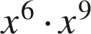

2. Write as a single monomial. 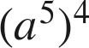

3. Write as a single monomial. 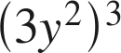

4. Write as a single monomial. 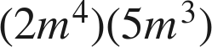

5. Write as a single monomial. 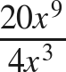

6. Find the value of . 